**Hypothesis Testing:**

It’s a process to determine whether to accept or reject null hypothesis(contradictory or alternative hypothesis), alternative hypothesis is the problem statement we need to find.

Example: we need to determine is there any difference in heights of student in class1 & class 2,

We can say it by saying that if mean1 > mean2 or mean2 > mean1

**Note: Read hypothesis testing on coin toss before reading this.**

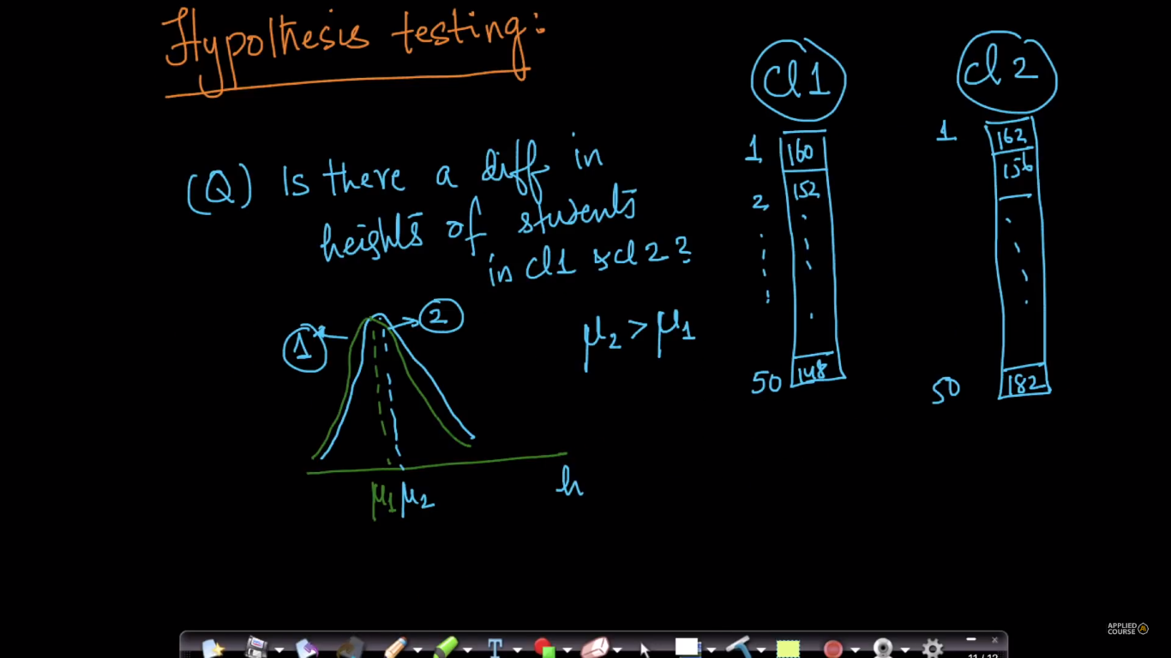

First we choose the test-statistic by performing an experiment:

Our experiment is mean2 – mean1, if it’s not equal to 0 then they are different.

Let’s say we get a value 10 cm by subtracting them.

Now we define null hypothesis, in this case our null hypothesis will be that subtraction of mean is 0, that means both class have same height ( no difference in mean1 & mean2 )

Now we will find the probability of getting 10 cm when there is no difference in mean1 & mean2, which also called as P-Value.

If our p-value < 5, then we reject the null hypothesis and accept the alternative hypothesis.

If p-value >= 5 then we accept the null hypothesis and reject the alternative hypothesis.

